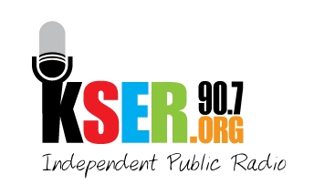
KSER 90.7
2623 Wetmore Ave.
Everett, WA 89201
425-303-9070
www.kser.org

AUCTION INFORMATION 2011
KSER Voice of the Community Award Celebration and 20th Birthday Bash

Benefits
- You showcase what your business or organization offers.
- You get your name and business promoted at the event, which will be attended by an attentive, community-minded audience.
- You help keep KSER alive and growing as a vibrant voice in our community.
- The KSER Foundation is a 501(c)(3) entity; your prize donation is tax deductible to the extent allowed by law

Deadline: Friday, October 21

Suggested ideas
The auction items that tend to bring in the highest bids are experiences and packaged items. For example:
- Boat cruise package
- Overnight kayak tour
- Flight simulator package
- Puget Sound flight package with dinner
- Private wine tasting party with music entertainment
- Restaurant package
- Evening of art package (theater tickets and dinner certificates)
- Get-away/spa package
- Sports package (tickets to local games with dinner certificate)
- Personal chef package with donated cookware

