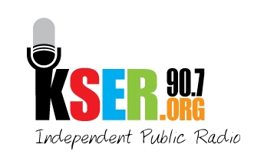
KSER 90.7
2623 Wetmore Ave.
Everett, WA 89201
425-303-9070
www.kser.org

September XX, 2011

<Auction Contact>
<Business Name>
<Address>
<City, State, Zip>

Dear <Auction Contact>,

KSER is celebrating 20 years of local, independent public radio service to our community with the 2011 Voice of the Community Award Celebration and 20th Birthday Bash! The celebration begins at 7 p.m., Saturday, November 5, in the Weyerhaeuser Room on the top floor of the Everett Station that offers a spectacular view. We’ll be toasting our past and future, having fun with a live auction and music, and recognizing positive voices in our community.

We invite Your Organization/Business to participate in this event as a donor of an item for our live auction. As an auction item donor, you’ll help raise funds to keep KSER alive and growing as a vibrant voice in our community. You’ll also be recognized during the event before an attentive, community-minded audience.

The auction items that tend to bring in the highest bids are experiences and packaged items. We encourage you to donate something that’s unique to your organization or business, but here are some ideas to get you thinking: boat cruise package, overnight kayak tour, flight simulator package, Puget Sound flight package with dinner, private wine tasting party with music entertainment, restaurant package, evening of art package (theater tickets and dinner certificates), get-away/spa package, sports package (tickets to local games with dinner certificate), personal chef package with donated cookware.

Please be sure to include any marketing collateral, brochures, and relevant details about the item you donate, so we can include an accurate description for potential bidders. The KSER Foundation is a 501(c)(3) entity; your prize donation is tax deductible to the extent allowed by law

We are anticipating a highly successful and well-attended celebration and auction. Show Your Organization’s friends, neighbors and colleagues your company’s support for KSER and the positive voices our community by becoming an auction item donor.

I look forward to talking with you about how you wish to contribute to the live auction for the KSER Voice of the Community Award Celebration and 20th Birthday Bash.

Sincerely,

<Board Member>
<Contact Info>

