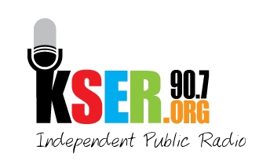
KSER 90.7
2623 Wetmore Ave.
Everett, WA 89201
425-303-9070
www.kser.org

Month xx, 2011

Name
Address
City, State, Zip

Dear Name,

Thank you for your generous donation of ____________ to the auction held on the evening of the KSER Voice of the Community Celebration and 20th Birthday Bash.

Thanks to you and other donors like you, we have raised ___ to help continue serving the North Puget Sound with local, independent public radio.

Sincerely,

Board Member
Contact Info

