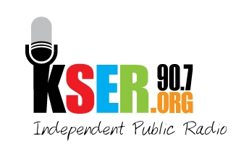
KSER 90.7
2623 Wetmore Ave.
Everett, WA 89201
425-303-9070
www.kser.org

EVENT INFORMATION
KSER Voice of our Community Awards Celebration
and 20th Birthday Bash
Celebrating positive voices in our community and 20 years of local, independent public radio!
7 p.m., Saturday, November 5, 2011
Weyerhaeuser Room, top floor of Everett Station
3201 Smith Ave., Everett

Featuring:
- KSER Voice of the Community Award recipients and nominees
- Birthday celebration of KSER’s past, present and future
- Live auction
- Music

KSER VOICE OF THE COMMUNITY AWARD is an annual award that recognizes local voices that speak up about community or cultural concerns with positive results for the residents of Snohomish or Island counties. Nominations are accepted from the community and a selection committee of community members and KSER representatives identify the finalists and winners. This year, three awards will be presented for community and cultural impact to individuals, groups or businesses.

KSER 90.7 is an independent public radio station providing Snohomish and Island counties with local news, information and a wide range of cultural and music programs. KSER is listener-supported, commercial-free and exists to advance the common good in our community through public radio and other services dedicated to arts, ideas and civic engagement. Each week, KSER touches the lives of tens of thousands of people, creating connections, inspiring action and providing the information needed to make important decisions.

