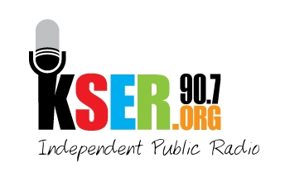
KSER 90.7
2623 Wetmore Ave.
Everett, WA 89201
425-303-9070
www.kser.org

KSER BROADCAST AREA
The contour below marks the area KSER is officially licensed to reach. Our actual broadcast range is significantly larger, but depends a great deal on terrain. Our listening and website audience is consistently growing.

