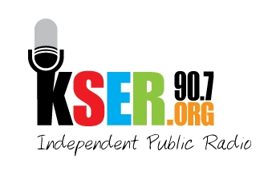
90.7FM KSER
2623 Wetmore Ave.
Everett, WA 89201
425-303-9070
www.kser.org

KSER Voice of our Community Awards 2011 and 20th Birthday Bash
Sponsorship Agreement and Payment Form

Deadline: Friday, Sept. 30
Complete this form and provide payment to the KSER Board Member who contacted you.
Or mail your completed form to: KSER Voice of our Community Awards Celebration, 2623 Wetmore Ave. Everett, WA 89201.

Date: ___________________ Contact Name: _______________________________________

Company or nonprofit name as it should appear in print and be announced:

Website:_______________________________________________________________________

E-mail address: ___________________________ Phone Number: _______________________

Address: _____________________________________________________________________

City/State/Zip: _________________________________________________________________

Select your sponsorship level
Level 1: $2,500 ____ Level 2: $1,500 ____ Level 3: $500 ____

Payment by credit card
CIRCLE ONE: Mastercard Visa AMEX Discover

Card Number: ____________________________________ Expiration Date: ______/______

Name on card:____________________________________ Security code on card: ________

Billing Address:_____________________________________________________________

Signature:________________________________________

Payment by check
_______ Check number for the full amount payable to KSER Foundation.

Important notes
By Friday, Sept. 30, KSER must receive:
- Your logo for event recognition
- Your company banner (if desired) for display at the event
Your free tickets to KSER Voice of our Community Awards Celebration and 20th Birthday Bash will be at will call. If your guests will be arriving at separate times, have them provide the sponsor’s name to receive their tickets. All guests will be requested to provide their name and contact information.

