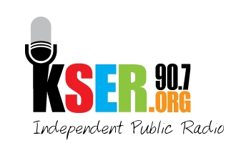
KSER 90.7
2623 Wetmore Ave.
Everett, WA 89201
425-303-9070
www.kser.org

SPONSORSHIP INFORMATION 2011
KSER Voice of the Community Award Celebration and 20th Birthday Bash

Benefits
- You support the recognition of important voices that positively impact our community.
- You reach an attentive audience at the awards celebration and an affluent, educated, and community-oriented audience throughout Snohomish and Island counties that listens to 90.7 FM for local news and culture not found anywhere else.
- You help keep KSER alive and growing as a vibrant voice in our community.

Deadlines:
- Friday, September 30 for full event recognition package
- Friday, October 21 for partial event recognition package

Level 1: $2,500
- On-air business name recognition 52 times during the year as a sponsor for a local KSER program, commentary, or conversation of your choice (once a week for a year)
On-air business name recognition sounds like this: “Support for this local program is made possible by KSER members and Your Business Name.”
- On-air business name recognition 12 times during morning or afternoon local news drive-times (once a month for a year)
- Website recognition for a year on KSER’s Business Directory page
- 8 tickets to KSER Voice of the Community Awards Celebration
- *Event Recognition Package

Level 2: $1,000
- On-air business name recognition 12 times during morning or afternoon local news drive-times (once a month for a year)
- Business Believer announcement 12 times during weekday music shows (once a month for a year)
- Website recognition for a year on KSER’s Business Directory page
- 6 tickets to KSER Voice of the Community Awards Celebration
- *Event Recognition Package

Level 3: $750
- On-air business name recognition 12 times during morning or afternoon local news drive-times (once a month for a year)
Business Believer announcement sounds like this: “We would like to thank Your Business Name for supporting KSER as a Business Believer.”
- Website recognition for a year on KSER’s Business Directory Page
- 4 tickets to KSER Voice of the Community Awards Celebration
- *Event Recognition Package

Level 4: $500
- Business Believer announcement 12 times during weekday music shows (once a month for a year)
- 2 tickets to KSER Voice of the Community Awards Celebration
- *Event Recognition Package

*Event Recognition Package
- Your company verbally recognized during the event
- The opportunity to display your company banner at the event
- If you register as a sponsor by September 30:
  - Your company name and logo on event materials, including the KSER website
  - Your company name included with event-related media releases

