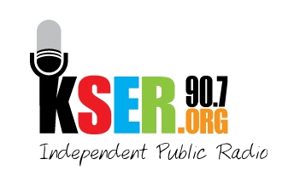
KSER 90.7
2623 Wetmore Ave.
Everett, WA 89201
425-303-9070
www.kser.org

DETAILS FOR BOARD MEMBERS REGARDING SPONSORSHIP
KSER Voice of the Community Award Celebration and 20th Birthday Bash

NOT FOR DISTRIBUTION

Our goal: $3,000 in sponsorships

Your responsibility:
- Identify potential sponsors you know that would be a good fit for KSER and make a list of five to contact.
- Call or email Becky with your five businesses, organizations or individuals and confirm that there are no conflicts or relationships currently being built.
- Connect with your five and tell them about:
  - KSER and how we serve Snohomish and Island counties as an independent voice for local news and culture and how a vibrant community radio station is critical to the health of our community.
  - The KSER Voice of the Community Award and how for four years in a row KSER has recognized and celebrated individuals who have been a positive voice in our community
  - How they can help celebrate our community’s voices and keep the KSER voice alive and growing through a sponsorship

Start now:
- Sponsorships can be obtained with complete event recognition packages, now through Friday, September 30. Sponsorships with partial event recognition packages can be accepted now through Friday, October 21
- If you receive a check from your sponsor, please ensure that you give it to John Thielke.

Additional details about $2,500-level sponsorship benefits:
Sponsors would receive business name recognition 52 times during the year as a sponsor for a local KSER program, commentary, or conversation of your choice (once a week for a year). This includes:

- Monday afternoon conversation during Sound Living: Jerry Cornfield, Sue Frause, Kristin Kelly
- Tuesday afternoon commentaries during Sound Living: Jim Hightower, World Ocean Radio, Human Rights Digest, Mark Hale’s “Sand in the Gears
- Wednesday afternoon conversations during Sound Living: Scott Wilson, Darrell Gray, Bill Becker
- Thursday afternoon’s local naturopathic health show: Sound Living-The Healthy Edition
- Friday afternoon conversations with Snohomish and Island County guests: Sound Living
- Monday Public Affairs (week): (1) Power of Peace, (1) America’s Disappeared, (2) Snohomish County League of Women Voters’ Magazine on the Air, (2) Face Your Future, (3) Part of the Union, (3) Radio Labor Journal, (4) Focus on Aging, (4) Community Life, (Last Tuesday) Getting Your Dough To Rise

