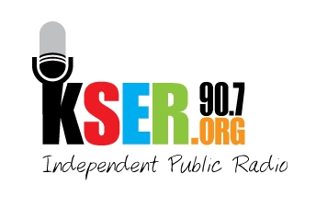
KSER 90.7
2623 Wetmore Ave.
Everett, WA 89201
425-303-9070
www.kser.org

Month xx, 2011

Sponsor Name
Address
City, State, Zip

Dear Sponsor Name,

Thank you for your generous sponsorship of the KSER Voice of the Community Celebration and 20th Birthday Bash.

Thanks to you and other sponsors like you, we have raised ___ to help continue serving the North Puget Sound with local, independent public radio.

Sincerely,

Board Member
Contact Info

