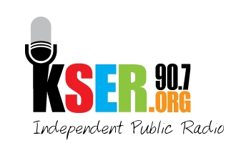
KSER 90.7
2623 Wetmore Ave.
Everett, WA 89201
425-303-9070
www.kser.org

September XX, 2011

<Sponsor Contact>
<Sponsor Name>
<Address>
<City, State, Zip>

Dear <Sponsor Contact>,

KSER is celebrating 20 years of local, independent public radio service to our community with the 2011 Voice of the Community Award Celebration and 20th Birthday Bash! The celebration begins at 7 p.m., Saturday, November 5, in the Weyerhaeuser Room on the top floor of the Everett Station that offers a spectacular view. We’ll be toasting our past and future, having fun with a live auction and music, and recognizing positive voices in our community.

We invite Your Organization/Business to join us as a sponsor for this event. As a sponsor:
- You’ll be supporting the recognition of important voices that positively impact our community.
- You’ll reach an attentive audience at the awards celebration and an affluent, educated, and community-oriented audience throughout Snohomish and Island counties that listens to KSER for local news and culture not found anywhere else.
- You’ll help keep KSER alive and growing as a vibrant voice in our community.

We are anticipating a highly successful and well-attended celebration and auction. Show Your Organization’s friends, neighbors and colleagues your company’s commitment to KSER and the positive voices our community by becoming a sponsor.

I look forward to talking with you about the sponsorship package that will best fit your needs.

Sincerely,

<Board Member>
<Contact Info>

